# Working With Dataset

|  |  |
| --- | --- |
| Date | 6th November 2022 |
| Team ID | PNT2022TMID14777 |
| Project Name | Project - Analytics for hospitals health care data |

**Name: Kavipriya T**

# Roll no: 7179KCTKCTKCTKCTKCTKCTKCT19BCS031

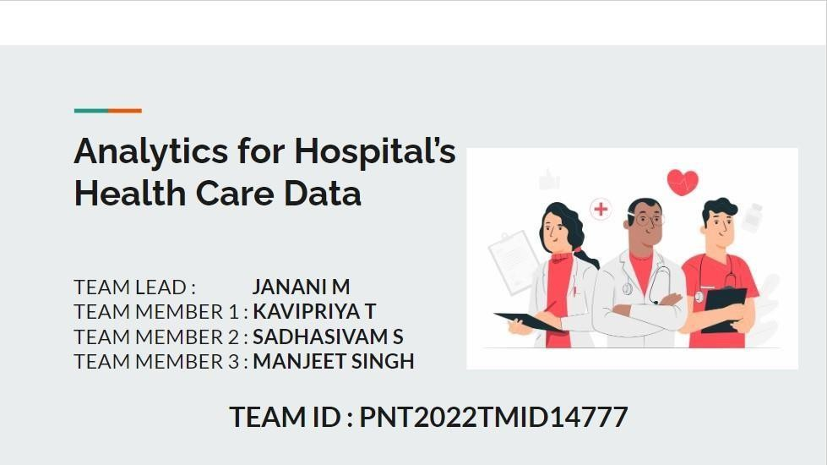

## Loading the Dataset:

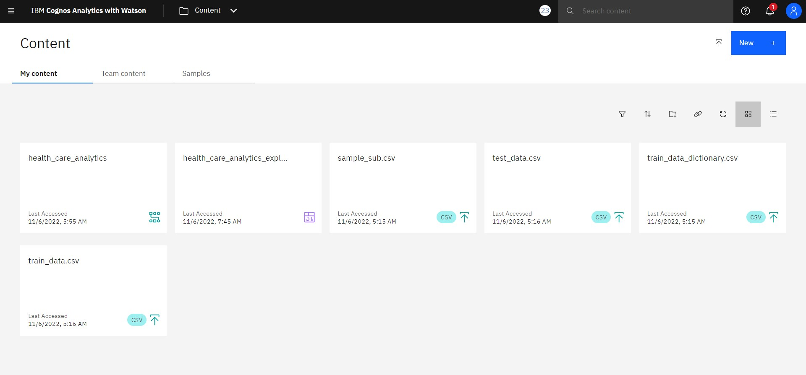

**Data Exploration:**

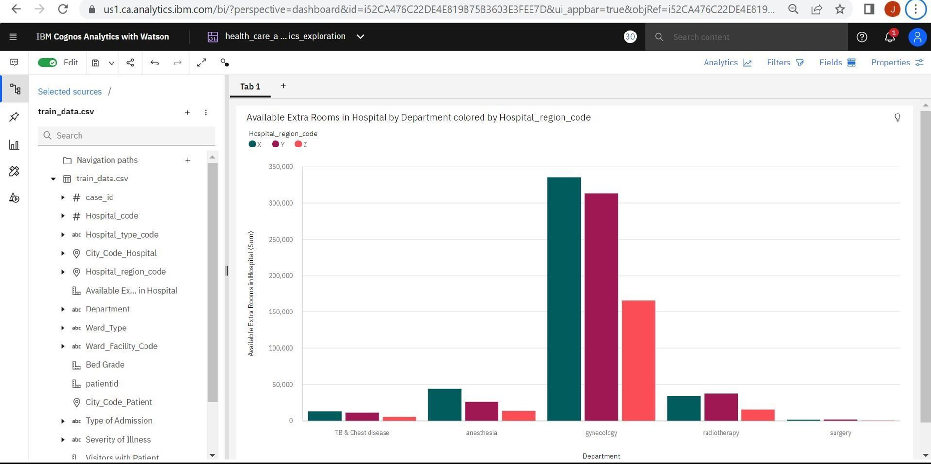

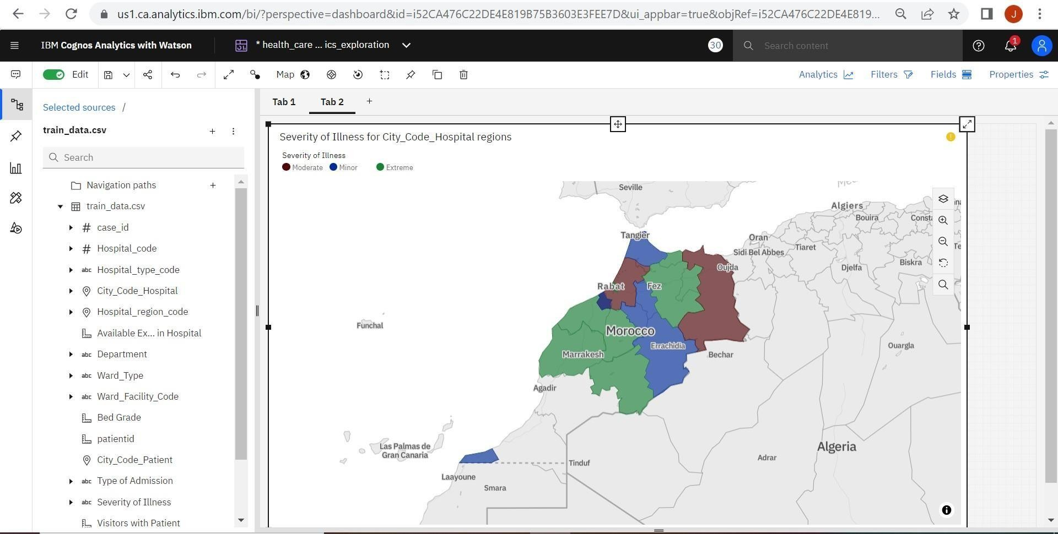

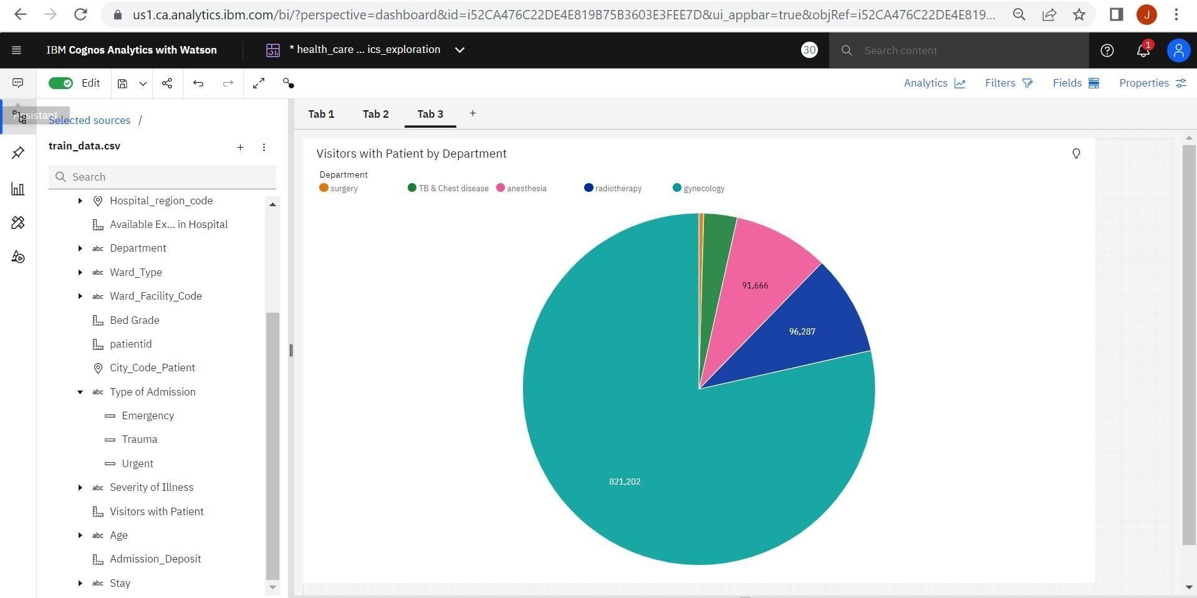

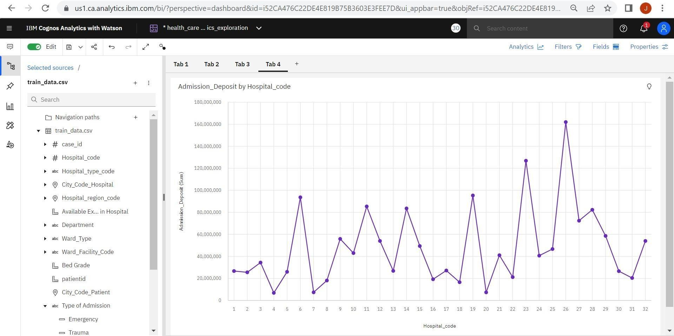

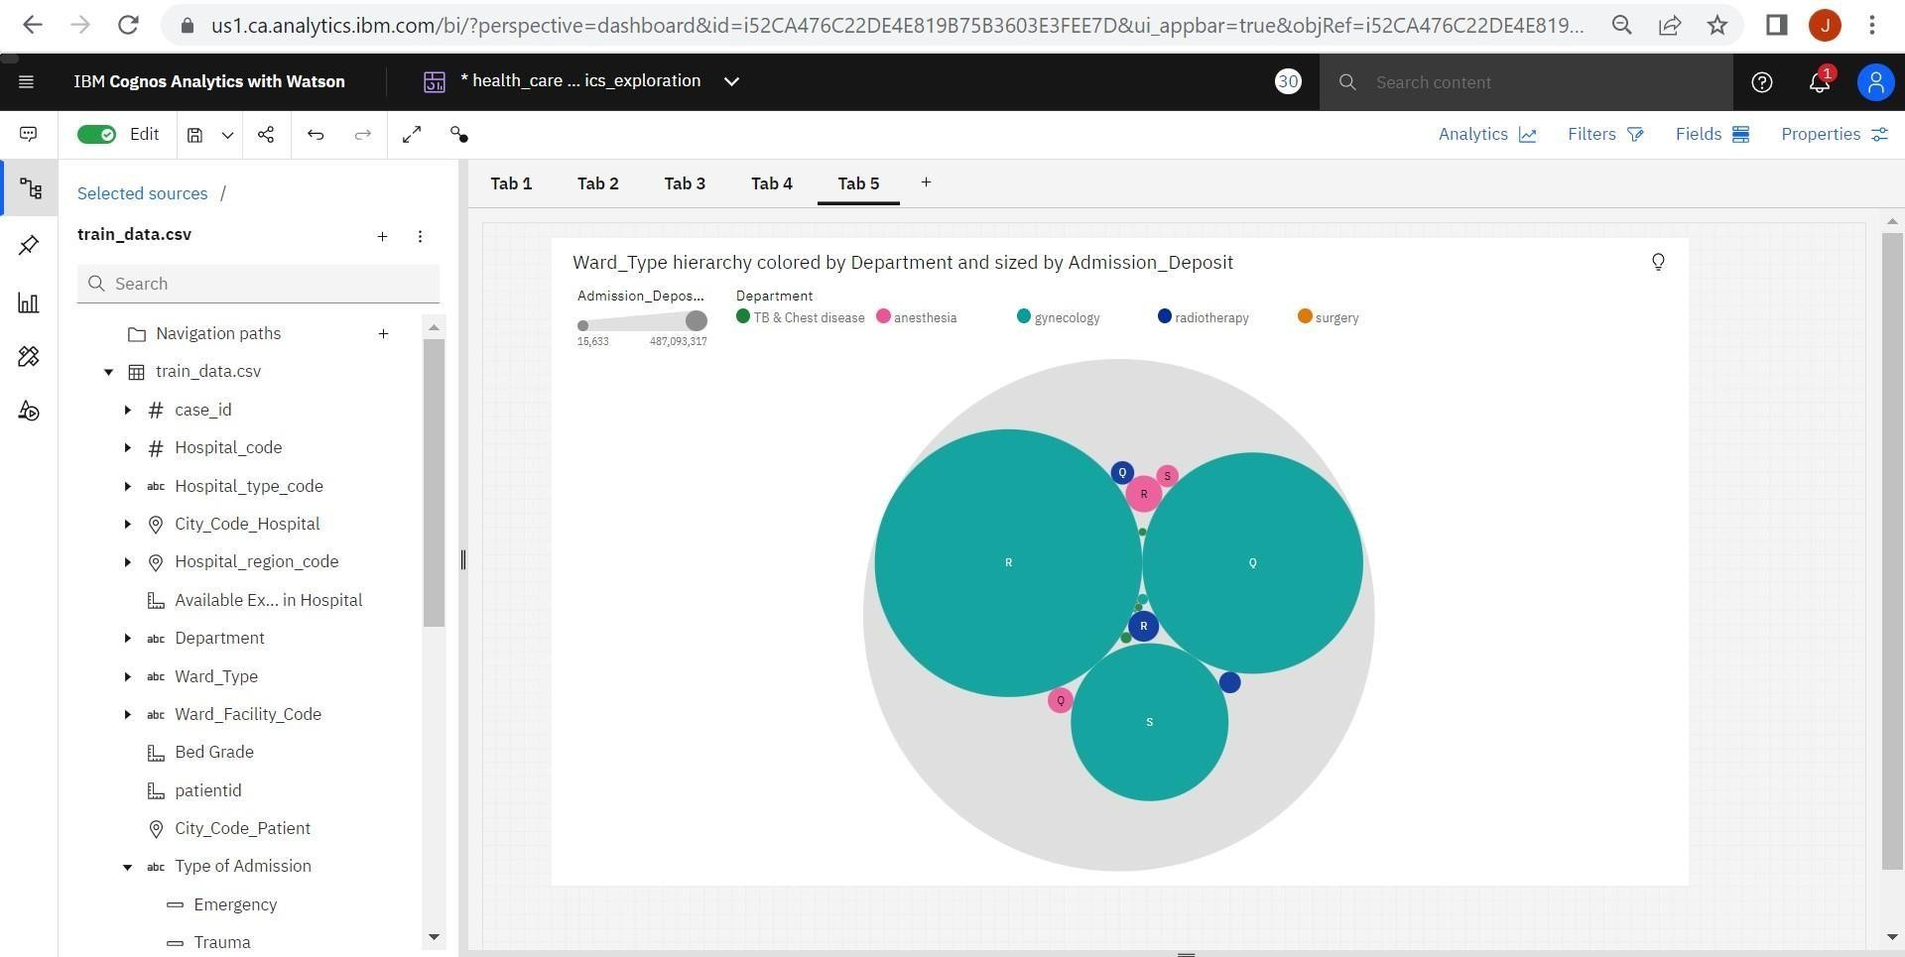

## Data Exploration Link:

https://us1.ca.analytics.ibm.com/bi/?perspective=dashboard&pathRef=.my_folders%2Fhealth_care_analytics_exploration